In

Iraqi Kurdistan

Mission Report

26 August to 04 September 2018

A visit carried out by the Honorary President of
Apiculteurs sans frontières
(Beekeepers without Borders)

Robert YVRARD

Mission report

In liaison with the KRG - the Paris office of the Iraqi Kurdistan Regional Government - and after a visit to the said KRG headquarters by myself and the President of “Apiculteurs sans Frontières” (Beekeepers Without Borders) , Dr. Yves RONDELET, and in view of the warm welcome that was reserved for us, we decided that I should carry out this mission since I am familiar with Iraq and in particular Iraqi Kurdistan. The Mission had to be safe and well planned.
The planning was established by Dr. Sami YOUSSEF of Dohuk University (Iraqi Kurdistan) and the University of Montpellier (France) and Professor HONAR, also from Dohuk University.
On-site logistics were provided by Mr. ZUHEIR, a Franco-Kurd from Kani-Maze, himself a beekeeper.
It was therefore with great emotion that I returned to this country and its multimillennial history. My objective was to visit Dohuk University, the Faculty of Agriculture and especially beekeepers in the field, to study the feasibility of a Franco-Kurdish cooperation beekeeping project.
It should be noted that there are three governorates in Iraqi Kurdistan:
1. Dohuk,
2. Erbil
3. Sulaimaniye.
Our project will focus on Dohuk and its region.
I will briefly detail the results of my mission.
August 27, 2018:
Visit to the French Consul in Erbil, Dominique MAS, with Mr ZUHEIR. Good communication.
We explained our proposition to work with Dohuk University. The Consul confirmed our idea and advocates making contact with small groups in the field but informs us that the notion of clubs and associations is little known in Kurdistan.
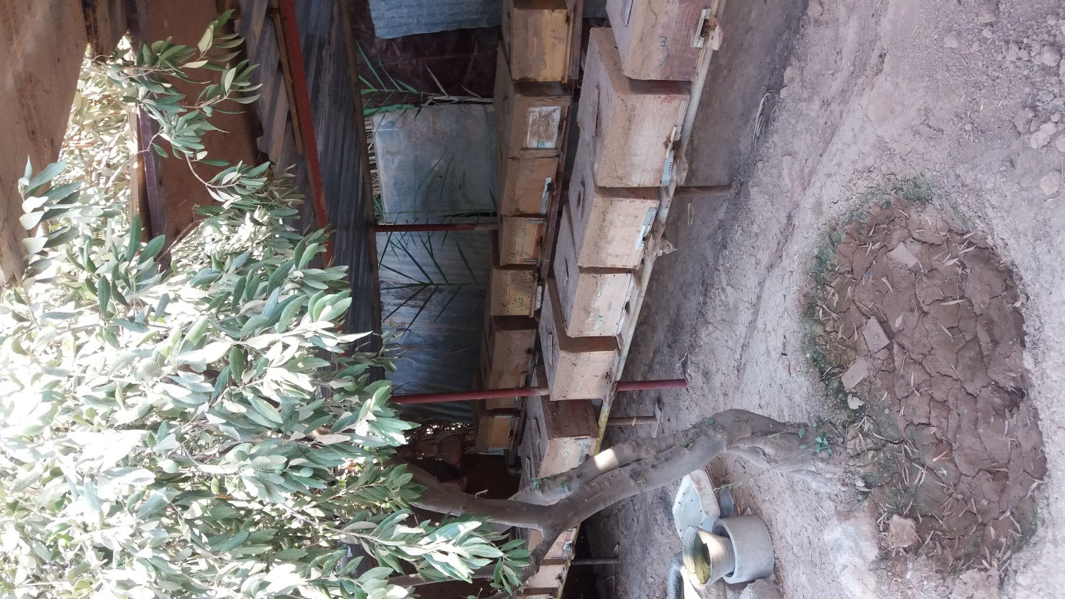
August 28, 2018:
Visit to Dohuk University. Meeting with the Director General. Very nice home. Professor HONAR details the project with students for the preparation of a Masters degree in Environment and Beekeeping.
Visit to an apiary in the Faculty of Agriculture: the varroase treatments are very varied and we noted the possibility of residues in the honey due to the non-use of honey supers. Indeed, most Kurdish beekeepers use the Langstroth brood body with no supers.
August 29, 2018 :
Visit to a Yesidie village with Dr. Haji YAZDEEN. We met with 5 beekeepers in the village of Charya especially with a very good beekeeper Sharif ISMAEL who manages a hundred hives under cover in his garden and produces a very good honey. In answer to the question "what anti-varroa treatment do you use ? He takes out a bottle of Probee ! On the other hand, I saw bees with deformed wings at other beekeepers.
August 30 and 31, 2018:
Departure at 6:00 am with Professor HONAR and another lecturer to go to Kani Masi and Mr. ZUHEIR's house; Two hours drive in the mountains to reach the village of Kani Masi, close to the Turkish border with all the problems related to this proximity ...
We received a very good welcome from Mr Zuheir who took me to visit his apiary composed of sixty hives. (including hives in production, nuclei, etc.)
The two lecturers returned to Dohuk and Mr. ZUHEIR looked after me for two more days. We visited 7 beekeepers who all have between 10 and 30 hives. The Anatolian honeybee (Apis mellifera anatolica) is the subspecies here.
Kani Mazi is 1000 meters above sea level, and despite this, the temperature was around 40 degrees Celsius. The queens have partially stopped laying as a result of the drought. The apicultural practice seems pretty messy, with little anti-varroa treatment because the presence of the parasite is supposedly considered to be very minimal. The valley bottoms remain lush and green because of the presence of water and many springs.

September 1, 2018 :
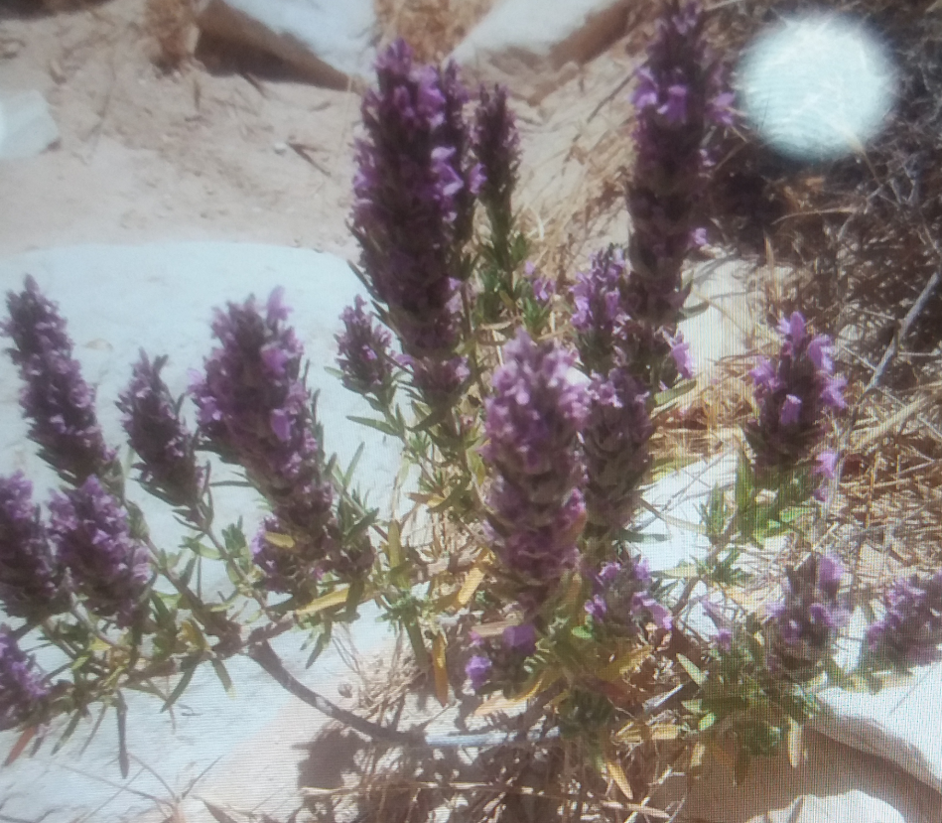
Morning visit to a traditional beekeeper with cylindrical hives. An excellent apiary with hives under cover again, he tells us his varroa treatment is thyme as fuel in the smoker. Excellent honey. Anatolian bees showing little aggressivity.
We visit a 1400-year-old church cut out of the rock face, destroyed and then restored. In the afternoon, we return to Dohuk with Mr. ZUHEIR.
Night in a hotel
September 2, 2018:
Visit to the Director of the Faculty of Agriculture, Dr. Kemal DOSKI. We explain our mission plan and he points out that he can help us as long as any future project is endorsed by the KRG.
Visit at noon to a Syrian refugee camp of about 2600 people where I was invited to give my opinion on a site for 2 hives which I of course gladly did. This small project is dear to Dr. Sami YOUSSEF's heart.
We have lunch next, Professor HONAR, Mr. ZUHEIR and myself. After the meal, Professor HONAR leaves us, while we visit a reseller of beekeeping equipment, Mr. Ismael HUSSEIN of Dohuk. An experienced beekeeper on Mount Sinjar before the hostilities, his honey was awarded a gold medal at an international beekeeping congress in Egypt. He shows us various products used in the fight against varroa (including Apistan of unknown origin) and Turkish Probee.
I then meet Mr. ZUHEIR at his sister and daughter’s house in Dohuk. There, I enjoy a well-deserved rest, before leaving for Erbil airport two hours away. My return was assured by a rental car thanks to a friend of Mr. ZUHEIR.
End of mission

My conclusions :
This mission was very interesting both academically, apiculturally and at the human level. Certainly, although somewhat modified, the original goal was achieved, that is to establish a basis for a Franco-Kurdish apiculture cooperation project both at University level and in the field with local beekeepers.
So in consultation with Professor HONAR and his Master’s students I established the following two test areas:
• one in Charya with chairman Sharif ISMAEL,
• the other in Kani Masi with chairman ZUHEIR.
This part will be supervised remotely with qualified members of the APISF board: Dr. Max WESTBY and Dr. Yves RONDELET.
Finally, in terms of helping beekeepers with hive disease treatments, the environment, pesticides, beekeeping practice, etc., it will be necessary to train trainers. This is thanks to the logistics of the Faculty of Agriculture and Dr. VEHEL (doctor of animal nutrition, doctorate passed in Great Britain) in connection with the University of Dohuk.
This programme could take three years. It goes without saying that we will need financial support for the project.
Finally, I must thank everyone who facilitated this mission:
• Mr. Reivan HUSSEIN from KRG in Paris,
• Dr. Sami YOUSSEF,
• Professor HONAR from Dohuk University,
• Dr. VEHEL from the Faculty of Agriculture,
• Dr. Hadji YAZDEEN,
• And my faithful translator and friend, M. ZUHEIR,
• And all the others who, by their hospitality and kindness, have greatly helped me in my task.
Thank you all.
For this country which represents untold archaeological wealth of 6,000 years, Mesopotamia, the country of two rivers cradle of Agriculture, Land of our ancestors or old parents as Samuel Noah KRAMER liked to call it, for this country always present in my heart which has so much need of peace.
Robert YVRARD
Co-founder of APISF and Honorary President
[translated from the original French by Max Westby, 13/09/2018]

